Assignment -URL Shortner

Technical Architecture diagram
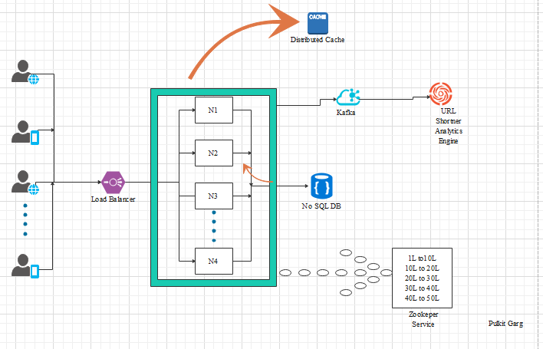

Brief :
Shortened URL will be combinations of numbers(0–9) and characters(a-Z) of length 7 (customizable as per the system requirement) which enables us to have 3.5 trillion no of short URL + some 3 digit random number.

Algorithm to map the short URL to any long URL:

We will maintain a counter when we have distributed hosts using Zookeeper.
- We take 1st million combinations from 3.5 trillion combination
- We have divided the 1st million into 1000 ranges of 1 million each which is maintained by Zookeeper
- 1 -> 1,000,000 (range 1) 1,000,000 -> 2,000,000 (range 1) …. (range n)999,000,000 -> 1,000,000,000 ((range 1000))
- Worker thread will come to Zookeeper and ask for an unused range. suppose W1 is assigned range 1, W1 will keep incrementing the counter and generate the unique number and generate TinyURL based on that.
- When a worker thread exhausts their range they will come to Zookeeper and take a fresh range.
- Guaranteed No Collision of tiny URL
- Addition of new worker threads is easy
- Worse case is we will lose a million combinations (if a worker dies) but that’s not as severe as we have 3.5 trillion combinations.
- When 1st million is exhausted, we will take 2nd million and generate ranges to work with.
- After getting a number ,we will append a 3 digit random number for handling security threats like :guessing the next short URL

Q:How many microservices will be created in this problem and what will be the
different responsibilities of each microservice. Just want to know how you
define microservices and what will be the name of those.
A:
As per the requirement,we will define 2 microservices
1) Url Shortner Processor It handles Short Url Creation and Retrieval of Long URL
2) URL Shortner Analytics Engine- It handles the analytics like no of time URL hit.
Q: How your system will be able to process one million requests per second. Just
define how you enable your microservices to process one million requests per
second?
By using
- Load Balancer we can increase the capability of server horizontally(attaching more server in spite of strengthen the single server)
- No SQL DB which can expand horizontally
- Apache Kafka to asynchronous request to analytics engine.

Q:What database or some other storage you will use to store its data.
Will you use some cache things in this project?
Database:We are using a NO SQL DB which will enables us to scale horizontally.
Cache:Yes we shall use the distributed cache like Redis Cache which can be created at different geographical location and we will store the data to the respective geograhically mapped cache which helps us in low latency.

Q:If anybody hit your shortened URL in the browser then It should hit the actual
URL to which It was generated.
A:By Using HTTP header :
Location :{Long URL}
status :302 or 303 (302-Found ,303 -Not Found)

